**Analysis of Airport Data Using Hive & Pig**

**Case Study**

*19CSE357 – Big Data Analytics*



***Date:*** *February 23, 2022*

**Group Details:**

|  |  |  |
| --- | --- | --- |
| S. No | Name of the Student | Roll No. |
| 1. | KOSURI DIVESH | CB.EN.U4CSE19422 |
| 2. | PENUGONDA KOUSHIK | CB.EN.U4CSE19449 |
| 3. | RAVELLA ABHINAV | CB.EN.U4CSE19453 |
| 4. | SINGADI SHANTHAN REDDY | CB.EN.U4CSE19459 |

**Dataset Description**

The main aim of the dataset is to develop a model for the airline data to provide a platform for new analytics based on the following queries as the problem faced is the existing has the ability to analyse limited data from the following databases

In our case study we are dealing with 3 different datasets named airports_mod, Final_airlines, routes

**Fields:**

**Airports_mod:**

* **Sample:** Goroka,Goroka,Papua New Guinea,GKA,AYGA,-6.081689,145.391881,5282,10,U,Pacific/Port_Moresby
* Dataset contains mainly unique Airport ID, Name of the airport, City of the respective airport, Country, 3-letter IATA code, Latitude & Longitude, Altitude, Timezone

**Final_Airlines:**

* **Sample:** 2,135 Airways,\N,,GNL,GENERAL,United States,N
* In this dataset it contains ID, Name of airline, Shortcut of airline, IATA, ICAO, Callsign, Country

**Routes:**

* **Sample:** 2B,410,AER,2965,KZN,2990,,0,CR2
* This dataset contains mainly 3-letter ICAO code, Airline ID, Source airport ID&Code, Destination ID & Code, Halts

**Outcome:**

We tried to explore detailed analysis on airline datasets such as listing airports operations, list of airlines having no halts etc., Here we mainly focussed on the processing of big datasets using hive component of Hadoop ecosystem in distributed environment.

At last, it will be useful in accessing and processing their user queries.

**Loading the Dataset:**

**Hive:**

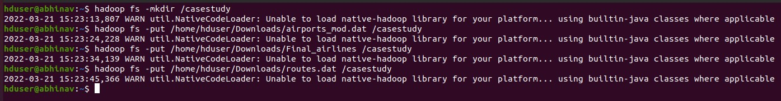

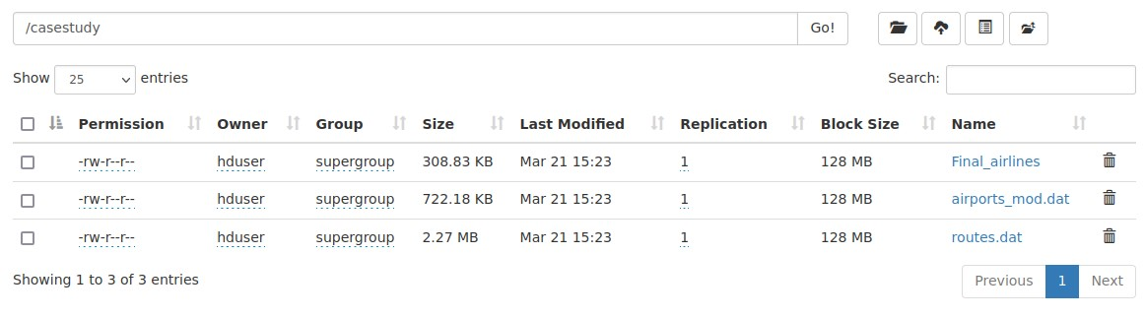

**Queries:**

**Hive:**

1. **Creating table airport for airports_mod dataset:**

create table airports (airport_id int,airport_name string,airport_city string,airport_country string,airport_faa string,airport_icao string,airport_lat double,airport_long double,airport_alt double,airport_timezone double,airport_dst string,airport_tz string) row format delimited fields terminated by ',';



1. **Creating table final airlines for Final_airlines :**

create table final_airlines (airlineID string,airline_name string, airline_alias string, airline_iata string, airline_icao string,callsign string,territory string, active string) row format delimited fields terminated by ',';

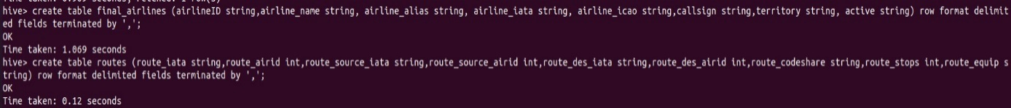

1. **Creating table route for routes.dat**:

create table routes (route_iata string,route_airid int,route_source_iata string,route_source_airid int,route_des_iata string,route_des_airid int,route_codeshare string,route_stops int,route_equip string) row format delimited fields terminated by ',';

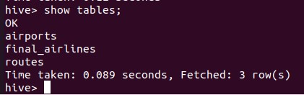

1. **loading data into airport table**

load data inpath '/airports_mod.dat' into table airports;

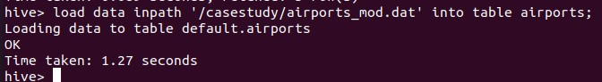

1. **loading data into final airlines table**

load data inpath '/Final_airlines' into table final_airlines;

1. **loading data into route table**

load data inpath '/routes.dat' into table routes;

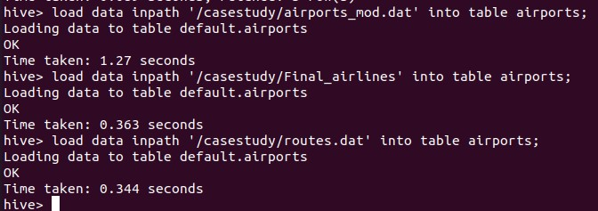

**RAVELLA ABHINAV – CB.EN.U4CSE19453**

# **Queries:**

## **Hive:**

1. Find all the airlines that are active and have an alias names

**Query:**

create table alias_not_null_airlines as SELECT * FROM final_airlines WHERE airline_alias IS NOT NULL AND active="Y";

**Result :**

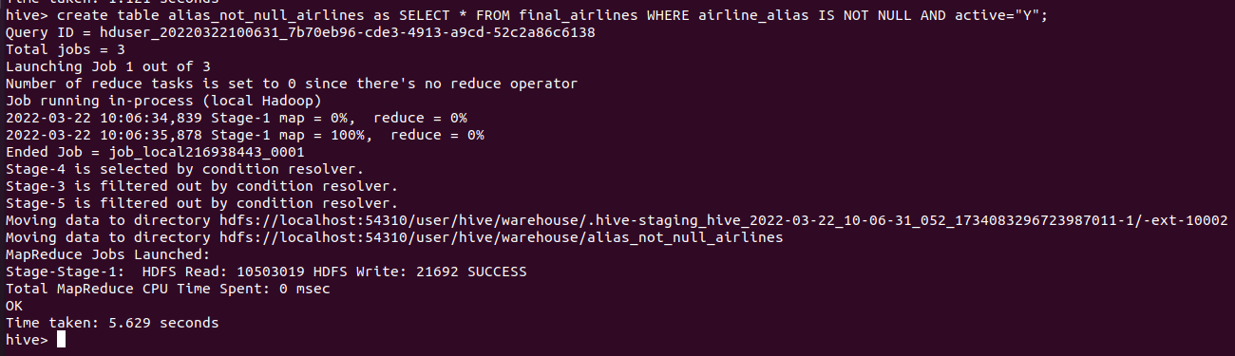

* **Querying the first 10 rows of the resulted table:**

**Query:** SELECT * FROM alias_not_null_airlines LIMIT 10;

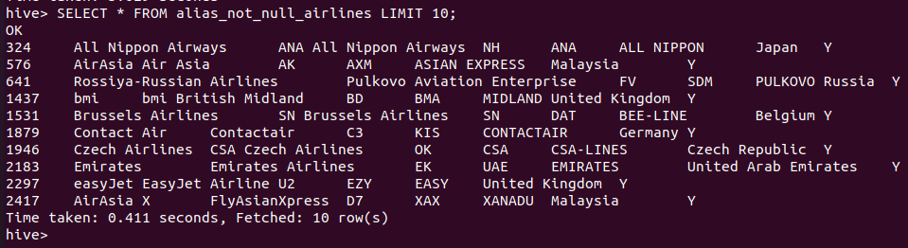

**Explaination:**

Job is to find list of airlines with alias names and are still operating (Active). This can be achieved by querying using ‘WHERE’ , ‘IS NOT NULL’ and ‘AND’ keywords. In the dataset, all the airlines that has no alias names have ‘NULL’ as the value in their respective cells. So ‘IS’ ‘NOT’ ‘NULL’ keywords are to be used to fetch all the values rows that have alias names and active status can be directly done using ‘WHERE’ clause.

1. Find the count of airlines that choose to have routes with 1 stop.

**Query:** select count(route_airid) from routes where route_stops like "%1%";

**Output:**

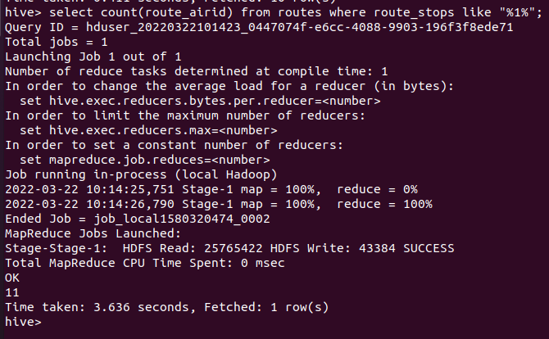

**Explanation:**

Job here is to find the total count of airlines that has one stop in its routes. So we are to query on routes table we already created using one of the aggregate function “count”.

1. select all the route id’s which have their no of stops equal to 1

2. Add the aggregate function “count” to count the no of ids that are resulted as a result of first query.

1. Find all airports in the world which lie at an altitude greater than 5000 ft.

**Query:** create table high_alt_airports as select * from airports where airport_alt > 5000;

**Result:**

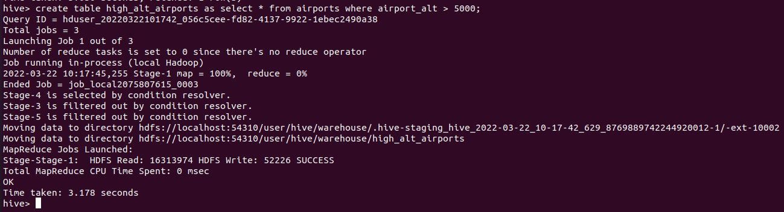

**Subquery:**

select * from high_alt_airports limit 10;

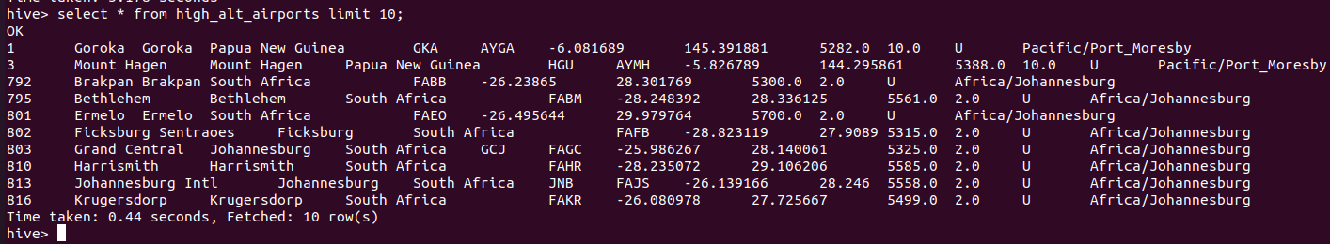

**Explaination:**

Job is to find out the list of all the airports at higher altitudes (alt > 5000 ft) we use a binary operator “>” to select all the airports that have their airport alt > 5000.

1. We first use the select clause to find all the airports above air_alt > 5000, create a new table high_alt_airports and store the result of above query in that new table.

2. Now we query the table for 10 airports with altitude above 5000 using ‘LIMIT’ keyword.

**PIG**

**Ravella Abhinav**

**CB.EN.U4CSE19453**

**Load datasets:**

**Airlines:**

**Query:**

airline = LOAD '/home/hduser/Downloads/airports_mod.dat' using PigStorage(',') as (airlineID:charArray,airline_name:charArray, airline_alias:charArray, airline_iata:charArray, airline_icao:charArray,callsign:charArray,territory:charArray, active:charArray);

**Output:**

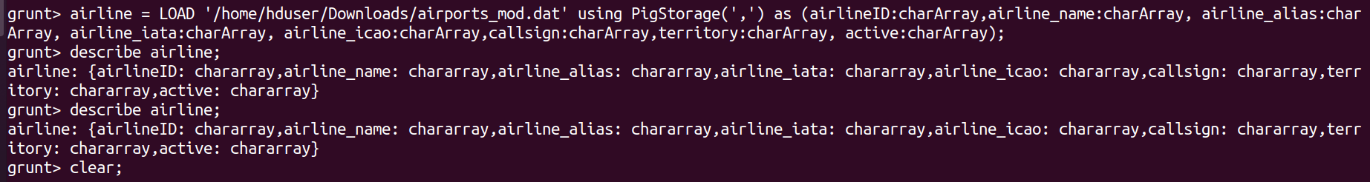

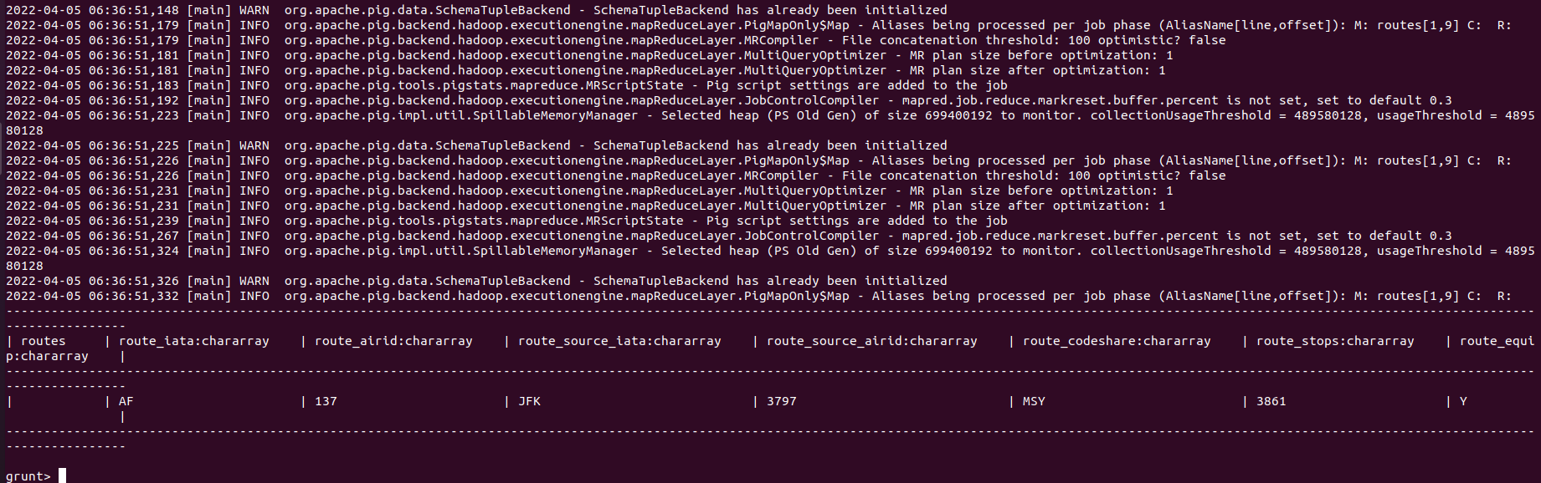

**Final Airlines:**

**Query:**

final = LOAD '/home/hduser/Downloads/Final_airlines' using PigStorage(',') as (airlineID:charArray,airline_name:charArray, airline_alias:charArray, airline_iata:charArray, airline_icao:charArray,callsign:charArray,territory:charArray, active:charArray);

**Output:**



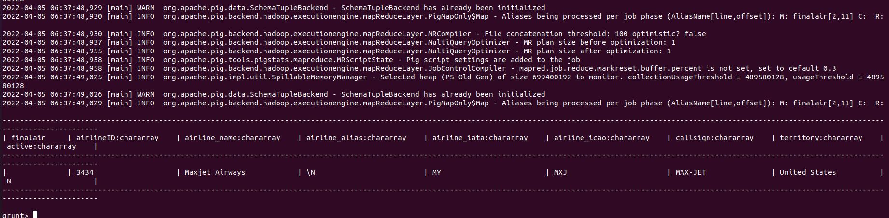

**Routes:**

**Query:**

routes = LOAD '/home/hduser/Downloads/routes' using PigStorage(',') as (route_iata:charArray, route_airid:charArray, route_source_iata:charArray, route_source_airid:charArray, route_codeshare:charArray, route_stops:charArray, route_equip:charArray);

**Output:**

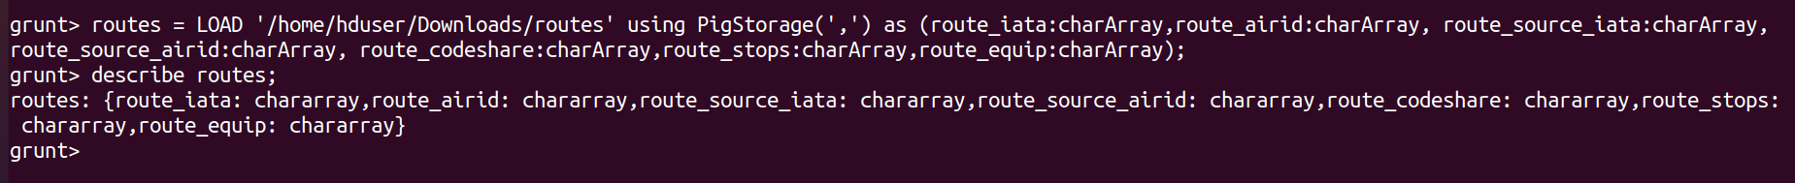

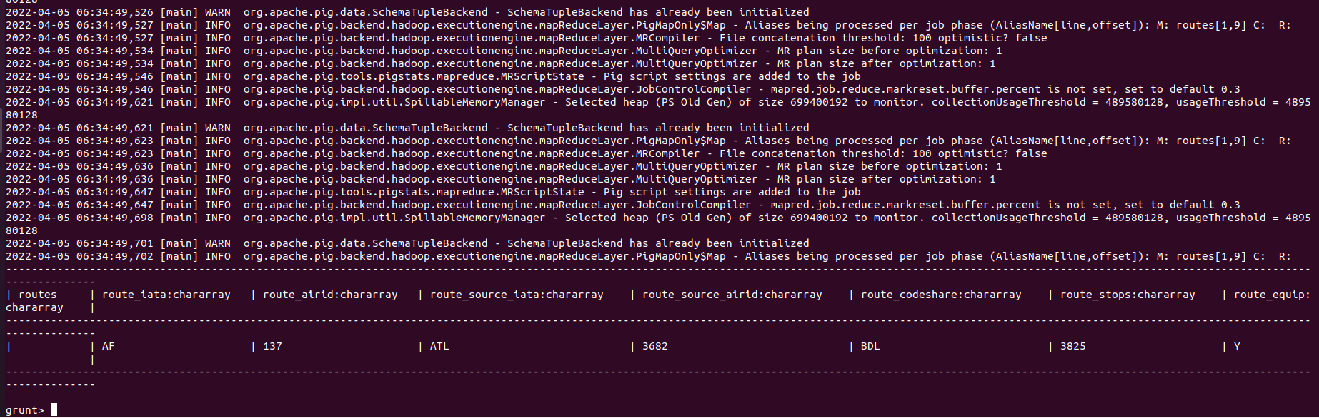

**Queries:**

1. **Find the airlines that are active:**

* active = filter final by Active == 'Y';
* limit = LIMIT active 50;
* dump active;
* dump limit;

**Output:**

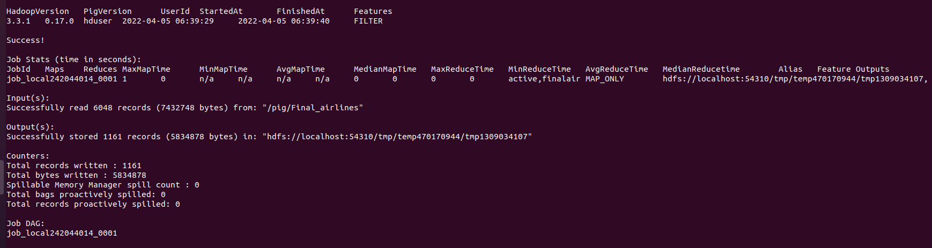

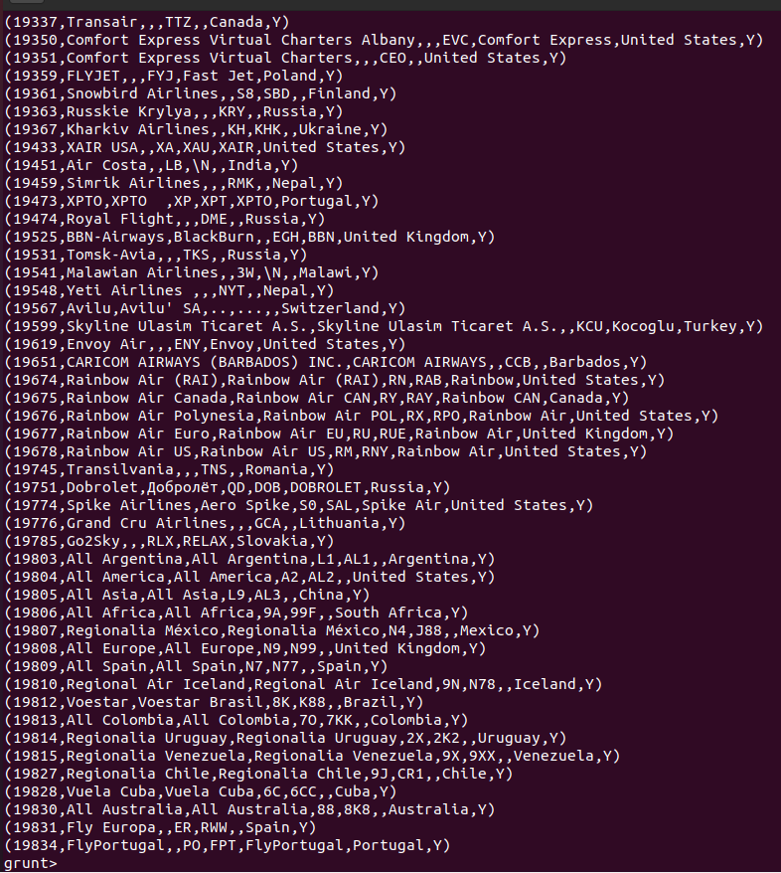

1. **Find the names of active airlines in territory ‘Unites States’?**

Query:

* active_airlines = filter filterair by active == 'Y';
* active_airlines_usa = filter active_airlines by territory == 'United States';
* find_active_airline_names_in_usa = foreach active_airlines_usa generate airline_name;
* dump find_active_airline_names_in_usa;

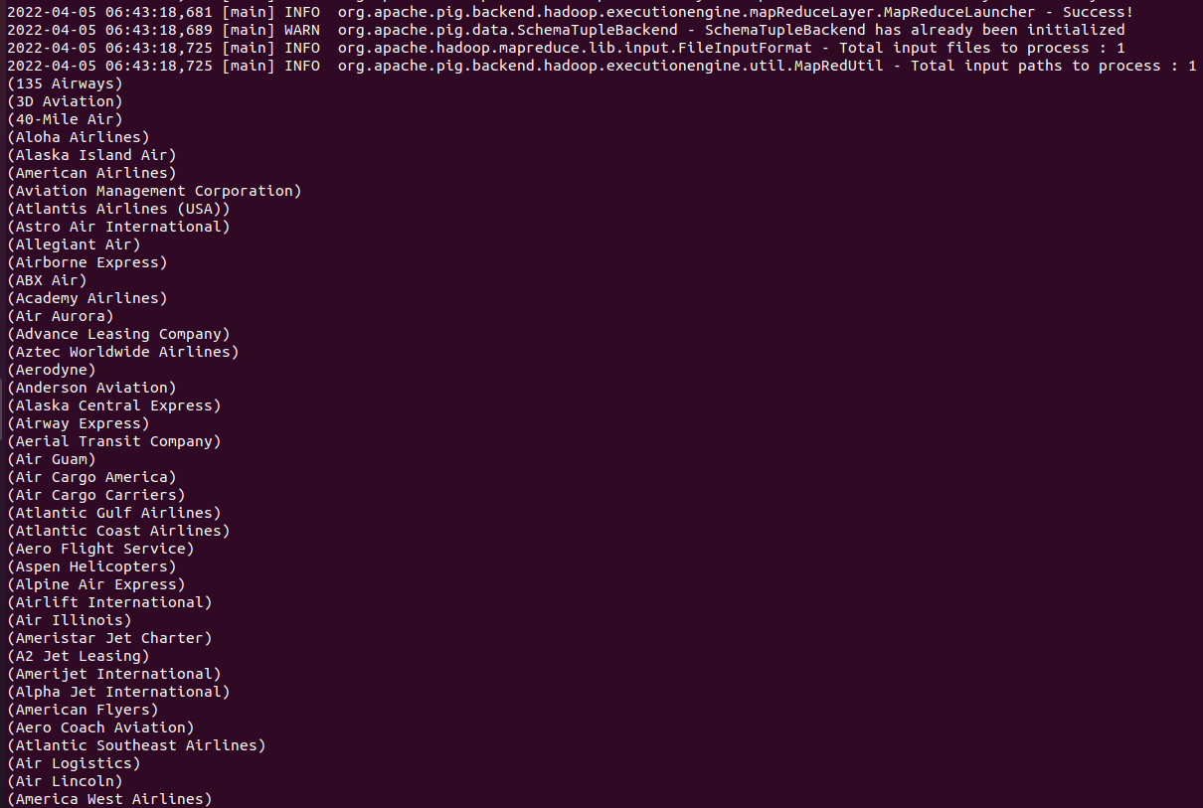

**Explanation:**

Job is to find all the airlines that are active in the United States which are currently active. So first filtering all the airlines that are active using filter and by keywords and saving them in a table and then querying that table to check for the United States territory using the same keywords and printing the airline names only using foreach and generate keywords.

1. **Get all the alias names of all airlines with airlineID**

**Query:**

* foreach_data = FOREACH finalair GENERATE airlineID,airline_name,airline_alias;
* dump foreach_data;

**Output:**

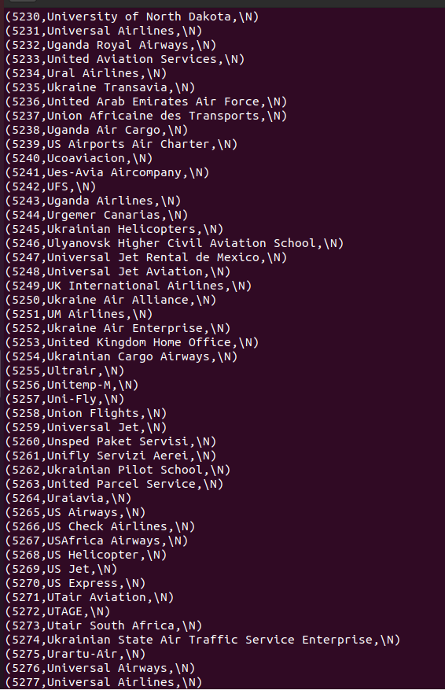

1. **Exploring group command:**

**Query:**

* Group_data = GROUP routes BY (route_iata,route_airid);
* Limit_group = LIMIT Group_data 10;
* Dump Limit_group;
* group_all = GROUP routes All;

**Output:**

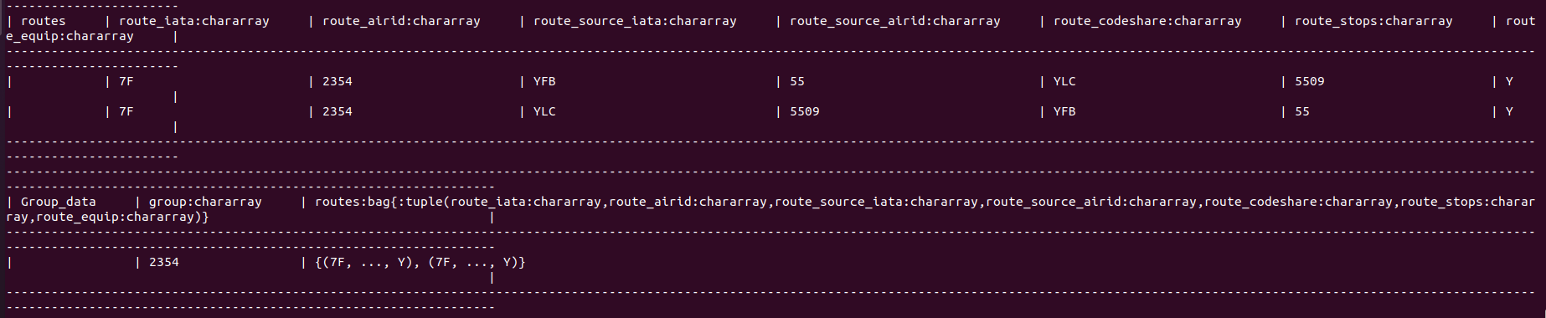

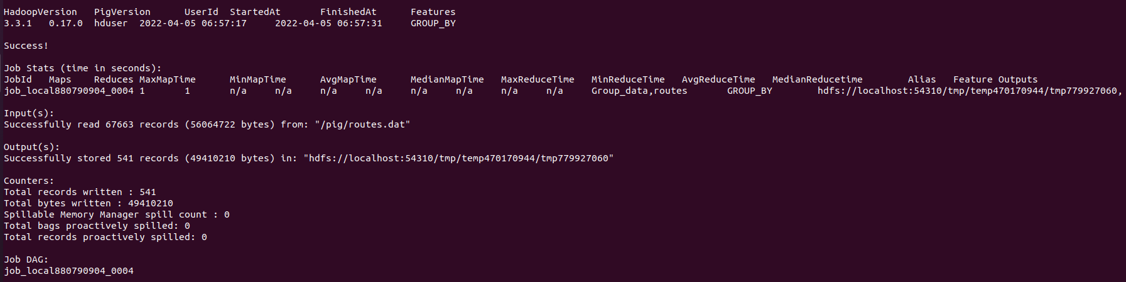



1. **Find the flights that has most number of stops?**

**Query:**

* stops = ORDER routes by route_stops DESC;
* dump stops;

**Output:**

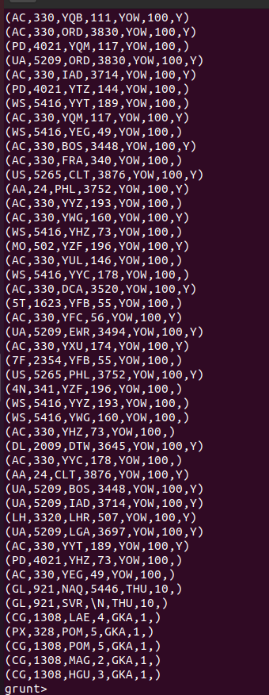

1. **JOIN Command:**

**Query:**

* right_join = JOIN finalair BY airline_iata RIGHT OUTER, routes BY route_iata;
* LIM = LIMIT right_join 10;
* dump LIM;

**Output:**

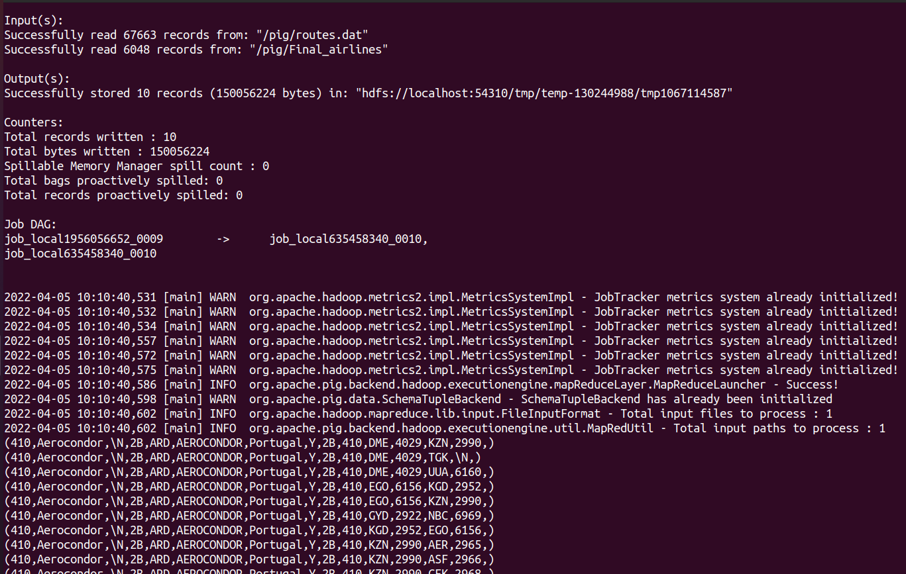

**Query:**

**Output:**